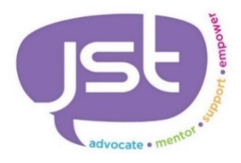
WDH SANDWELL

Referral Form
Contact Number:
Participant Details
Completed by:
Date of Referral:
Referring Agency:
EE Email:

WDH Ref Number:
Forename:
Title:
Email:
Ethnicity:
Contact Number:
Date of Birth:
Surname:
Gender:
Postcode:
Address:
Please return to The Platform Please return this form to james@juststraighttalk.org
Which of the following areas would you like support with? (Please circle all that apply)

Wellbeing Loneliness/isolation Health Issues Confidence

Budgeting Digital Skills Employability Skills Mental Health
Risk Assessment:

Risk to Self (please circle) None known Low Medium High

Risk to Others (please circle) None known Low Medium High

If any known risk, please detail
Please list any Disabilities/Mental Health Issues/Learning Disabilities:
Call 07396 490 884 for further information.
JST – Company Reg: 8259248

